Prescribing Tip No. 225 Date: 5th December 2018

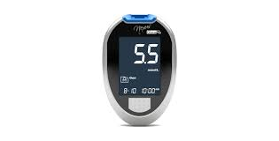

Updated Guidance on Choice of Blood Glucose Testing Meters, Strips and Lancets
on Sharepoint

Prescribing tip for information

The Medicines Optimisation team have recently worked together with local diabetes specialists to update local guidance on the choice of blood glucose monitoring meters and test strips. The updated guidance can now be accessed via Sharepoint. The guidance includes a range of blood glucose testing meters which:

- Meet current ISO standards;
- Possess a range of clinical features and highlights those patient groups for whom they are considered most suitable;
- Are compatible with cost effective testing strips.

NB. Requests for meters and testing strips outside of this guidance should be at the request of the Specialist Diabetes team only and where an individual patient need has been identified. Meters should be provided free of charge from GP surgeries or diabetes clinics. Patients should be dissuaded from buying their own meter – the prescribing of strips and lancets for patients’ own-purchased meters is not supported by the CCG.

The FreeStyle Libre® Sensor glucose monitoring system
- Policies on the availability of continuous and flash glucose monitoring devices (including FreeStyle Libre) have recently been developed and can be accessed via the Lancashire Medicines Management Group (LMMG) website.

- The FreeStyle Libre® device has been RAG rated RED. Red medicines are those where primary care prescribing is not recommended. These treatments should be initiated by specialists only and prescribing retained within secondary care. Diabetes specialists in hospitals and other specialists such as Diabetes Specialist Nurses will be responsible for prescribing for those diabetic patients who meet the access criteria.

To contact the Medicines Optimisation Team please phone 01772 214302

